# Color Similarity Experiment (SimilarityColorProject--V3)

1. Task Description

A cross shown on the left-hand side of the screen. Two circles will be flashed (Fovea and Periphery). Fovea(F) circles are close to the close and Periphery(P) circles far away from the cross.

3 types combination will happen: FF, FP, and PP.

The colour of the circles is chosen from a pool of 9 different colours.

Subjects decide the similarity level in that trial.

1. Script Description

* CircleLocation.qix

This script is used to decide the location of circles. Take cross position as reference, calculate an exact pixel value to be used for circles’ position.

Take 4 angle values as input, the angle is in degree.

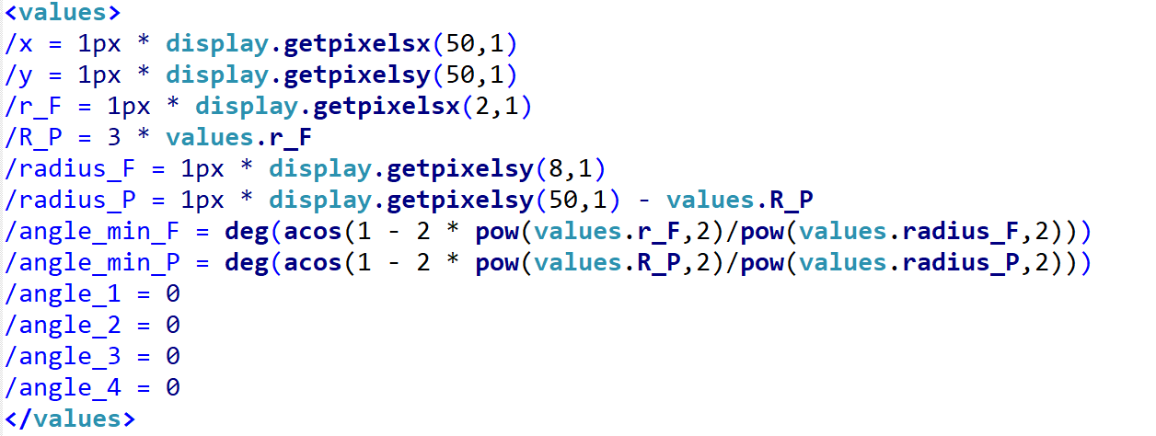

‘x’ and ‘y’ are the coordinate of cross;

‘r_F’: radius of fovea circles

‘R_P’: radius of periphery circles

‘radius_F’: distance between fovea circle and cross

‘radius_P’: distance between periphery circle and cross

‘angle_min_F’: In case FF, the minimum angle values between 2 fovea circles. (Exactly touch)

‘angle_min_P’: In case PP, the minimum angle values between 2 periphery circles. (Exactly touch)

* MainStructure.iqx

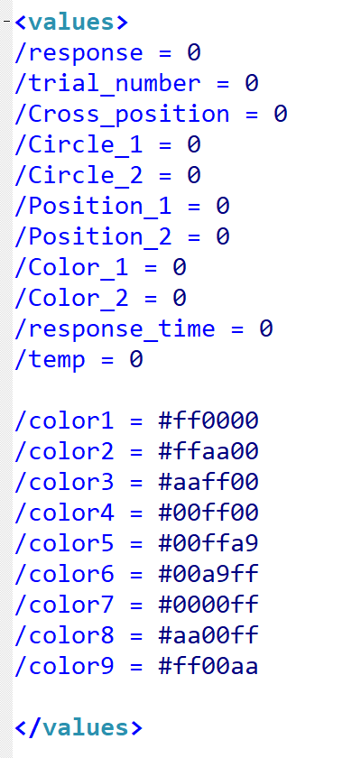Main script to operate the experiment. It consists of the strategy of this experiment.

<values> here define the 9 colours pool in this experiment (/color#). By using a hex value to describe colours, it is easy to change different colours.

Other values are used for collecting related values in each trial.

‘/response’: 0 – 7 to reflect the similarity level

‘/trial_number’: From 1-243. The experiment has 243 trials in total

‘/Cross_position’: +1 for left, -1 for right

‘/Circle_1’: -1 for Fovea and +1 for Periphery

‘/Circle_2’: -1 for Fovea and +1 for Periphery

‘/Position_1’: The angle value for circle 1

‘/Position_2’: The angle value for circle 2

‘/Color_1’: The colour of circle 1(From 1 to 7)

‘/Color_2’: The colour of circle 2(From 1 to 7)

‘/response_time’: The latency of subject response

* PictureAndText.iqx

Contains 4 circles and cross characteristics. (Initialise 4 circles and cross)

* BaseScript.iqx

Create list of combinations by colours and positions which will be used in these 243 trials.

* InstructionPage.iqx

Including the instruction pages at the beginning of the experiment.

* PracticeTrial.iqx

Including 9 practice trials

* ResponseStep.iqx

Including correspond response pages’ item

1. Strategy

* Calculate two circles’ exact position

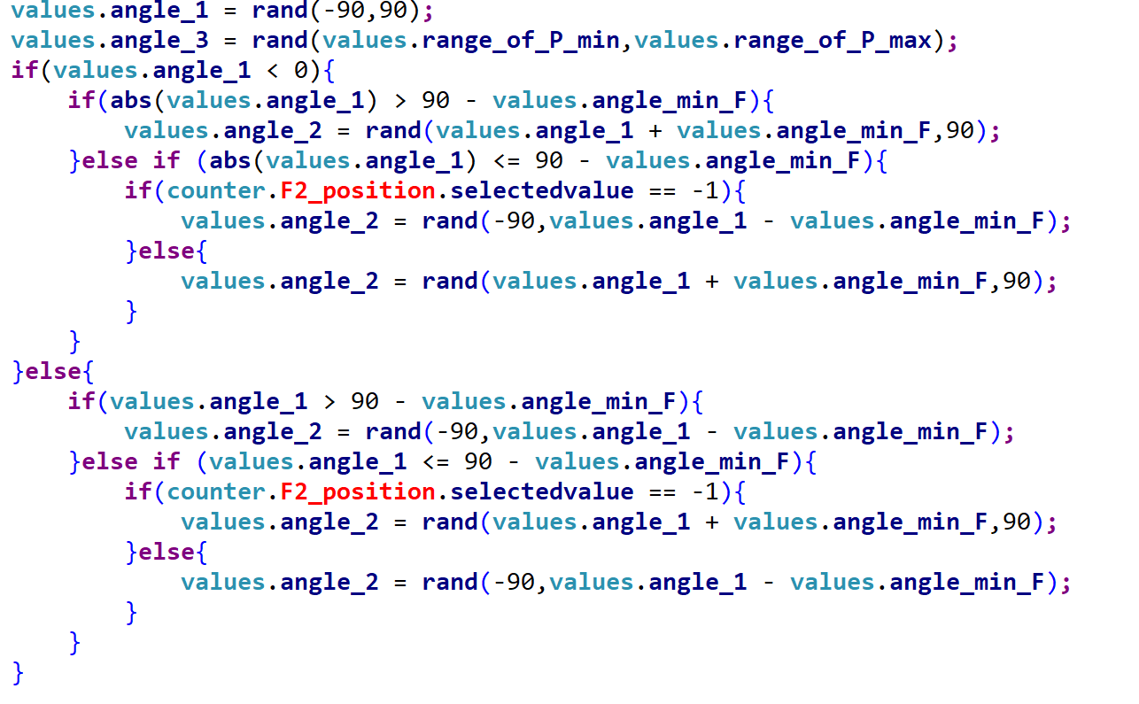

Because the cross is set on the left-hand side of the screen. So the circles can not show up for 360 degree. ‘angle_1’ and ‘angle_2’ are used for 2 fovea circles, and ‘angle_3’ and ‘angle_4’ for 2 periphery circles. Angle 1 can be chosen from -90 degree to 90 degree, then the corresponding angle 2 will have a different range(To avoid 2 circles touch together). So, this step is used to calculate an exact range of different circles.

* Total trial number: 243

If we just see the position, it will have 3 cases combination: FF, FP and PP.

Then we consider about the 9 colours we insert. If we want to show all the combinations with colours and positions. It will be

9 x 9 x 3 = 243 trials in total.

* Random Selected

We have 81 combinations by colours in FF case, 81 combinations in FP and another 81 combinations in PP. Prelist 243 combinations in BaseScript.iqx first and shuffle these items.

Use <counter> in Inquisit to randomise the order in different trial.

* Response Page

There is no masking step in this experiment. After two circles show up, two empty circles with the same size and position of the presented one will follow.

Subjects need to choose the similarity level of two circles colours. By putting hands on keyboard buttons ‘a,s,d,f,j,k,l,;’ to choose level from 0 to 7

* Feedback Page

After doing the response, a feedback page will come up to show what’s the button and similarity level they chose.

# Color Similarity Experiment (SimilarityColorProject--V3.2)

This version uses same strategy in previous version.

The differences points are:

1. Cross Position

The cross position now is located at the centre of the screen.

1. Circle Position Range

Because the positions of the circles are related to cross position. So now, the ranges of fovea and periphery are both (-180 to 180 degree)

1. Response page not using keyboard to choose the similarity level.

By using 8 disks to describe the level:

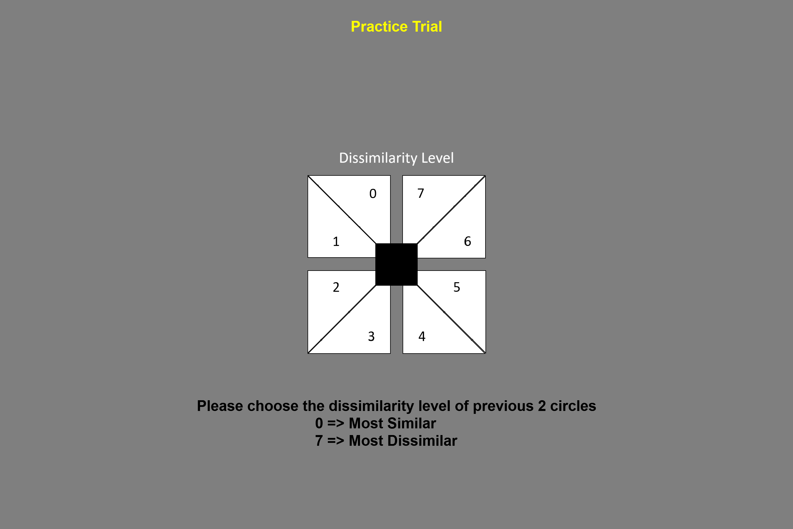

1. No more Feedback Page but using re-centre cursor page to increase correct rate.